Project Name | Multi-Cloud FinOps Optimization System
Background Information | Modern cloud infrastructure deployments are increasingly multi-cloud, leveraging both Amazon Web Services (AWS) and Microsoft Azure to ensure high availability and prevent vendor lock-in. However, managing infrastructure spend across heterogeneous cloud ecosystems introduces massive financial complexity. Cloud providers offer billing models like Reserved Instances (RIs) and Savings Plans (SPs) to reduce costs, but these models use completely different pricing structures, APIs, and telemetry schemas.  Without a unified optimization mechanism, enterprises experience severe cloud cost inefficiencies. This project focuses on building a zero-cost infrastructure framework that normalizes cross-cloud billing APIs, runs automated optimization logic, and delivers financial visibility through an interactive, serverless data portal.
Literature Review | Current academic research in cloud computing heavily favors performance optimization, auto-scaling algorithms, and load balancing, often overlooking structural cost optimization (FinOps). Industry whitepapers from organizations like the FinOps Foundation highlight that over 30% of enterprise cloud spend is wasted due to underutilized resources and "rate leakage" running variable workloads on full Pay-As-You-Go (PAYG) pricing despite having active, unapplied volume discounts.  Existing commercial software solutions (e.g., CloudHealth, Apptio) solve this by deploying heavy, continuous data ingestion agents that introduce API latency, potential vendor lock-in, and significant licensing costs. Academic literature lacks open, lightweight, serverless architectures that operate within a "write-rarely, read-constantly" data synchronization model to provide zero-cost financial observability for multi-cloud setups.
Statement of the Problem | Organizations deploying workloads across both AWS and Microsoft Azure face a fragmented operational landscape. There is no native, cross-provider tool capable of automatically consolidating billing data to prioritize and distribute compute commitments globally. Consequently, companies suffer from two primary issues:  - Commitment Underutilization: Pre-purchased reservation capacity goes unused in one business unit or cloud tenant while another unit buys identical compute capacity at standard on-demand rates.  - Rate Leakage: A complete lack of programmatic visibility to trace why active workloads are failing to match against unassigned cloud savings instruments.
Objectives | Objective 1: Design a cross-cloud normalization data model that standardizes telemetry schemas from the AWS Price List API and Azure Retail Prices API.  Objective 2: Implement a secure, password less authentication flow using OpenID Connect (OIDC) Workload Identity Federation to securely query multi-cloud telemetry without exposing long-lived credentials.  Objective 3: Develop a linear "Waterfall" reconciliation algorithm that simulates allocation priorities to map unutilized commitments to active Pay-As-You-Go compute instances.  Objective 4: Deploy a zero-operational-cost cloud dashboard architecture using a relational database layer and a Python-based web UI framework to deliver high-performance, real-time "What-If" commitment modeling.
Methodology | The project will be executed using data engineering and agile systems development lifecycle framework split into four main operational phases:  - Data Ingestion Engineering: Build stateless Python orchestration jobs executed via cron schedules. These jobs handle API data aggregation, pulling on-demand pricing, active reservation inventory, and historical compute usage matrix data.  - Database Schema Design: Construct a structured database architecture using an Azure SQL Database (Free Tier) to store the standardized billing entities, ensuring high read performance while staying within a strict 32GB storage cap.  - Algorithmic Modeling: Code the reconciliation logic using Python data science libraries (pandas, numpy). The algorithm runs a deterministic processing loop: it sorts all compute instances by hourly cost, identifies gaps where no discounts are applied, and attempts to match them against open commitment buffers.  - Interface Implementation: Package the system logic into an interactive user portal built via Streamlit and deployed onto a serverless hosting environment, enabling seamless presentation and real-time user testing.
Proposed Solution/  Expected Results | Successful pipeline execution running on a 24-hour cron interval, achieving a 0ms frontend API query latency by utilizing the pre-synchronized database layer.  - Live dashboard visualizations showing a top-level summary of total infrastructure spend, an interactive "Rate Leakage" grid highlighting unoptimized compute workloads, and a risk-buffered (80% target) financial simulator.  - A fully working deployment operating at exactly $0.00/month by maximizing perpetual cloud-free tiers.  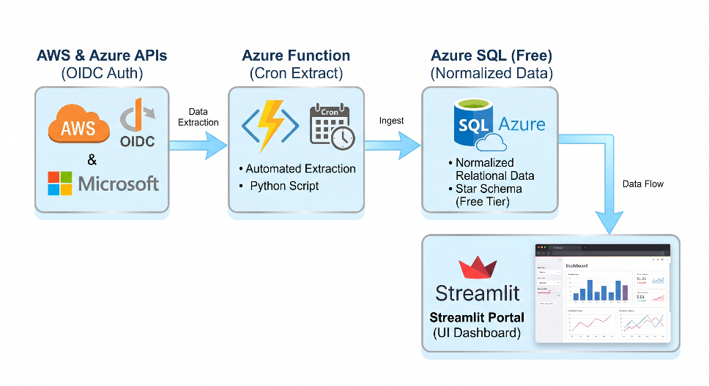
Detailed Scope of Work: | The scope of this project encompasses the end-to-end design, implementation, and validation of a zero-cost, serverless cloud financial operations framework. The work is explicitly divided into five core technical phases:  Phase 1: Ingestion & Pipeline Engineering (Serverless Layer)  This phase focuses on the automated extraction and ingestion of billing and utilization datasets from heterogeneous cloud environments.  - API Integration: Develop Python-based ingestion scripts to interface with the Azure Consumption Price Sheets API and the AWS Cost Explorer API.  - Serverless Orchestration: Deploy Azure Functions operating on a Consumption (Serverless) Plan. These functions will be configured with time-based triggers (Crontab schedules) to execute daily micro-batch data pulls.  - Secure Pipeline Authentication: Implement password less authentication mechanisms to eliminate hardcoded credentials. The pipeline will utilize OpenID Connect (OIDC) Workload Identity Federation to authenticate securely into the AWS environment, alongside Cross-Tenant Service Principals utilizing custom Azure Role-Based Access Control (RBAC) roles configured with minimum required permissions.  Phase 2: Data Engineering & Normalization Core  This phase addresses the structural differences between disparate cloud provider schemas, converting raw data into a clean, query able state.  - Schema Flattening: Build a processing layer within the Python backend utilizing the panda’s library to parse, flatten, and clean highly nested JSON payloads extracted from the cloud provider APIs.  - Standardized Normalization: Map diverse column schemas into a single, cohesive, unified tabular layout. The data transformation logic will align closely with the industry-standard FinOps Open Cost and Usage Specification (FOCUS) framework.  - Data Cleansing: Establish automated data-validation routines to detect and filter out malformed API responses, duplicate entries, or missing data points before they reach the storage tier.  Phase 3: Relational Storage & Database Design  This phase covers the architecture and implementation of the data layer required to support high-performance analytical queries without incurring operational costs.  - Database Provisioning: Deploy an Azure SQL Database instance utilizing the Azure Lifetime Free Tier (providing 100,000 vCores seconds monthly) to maintain a strict zero-dollar budget blueprint.  - Relational Schema Architecture: Design and execute a normalized relational schema optimized for write-rarely, read-constantly query patterns. This includes building dedicated tables for unified cloud costs, commitment metrics (Savings Plans and Reservations), and system audit logs.  - Performance Tuning: Implement clustered and non-clustered database indexes on high-frequency query fields—specifically timestamp columns and cloud provider identifiers—to guarantee sub-second analytical query rendering in the user interface.  Phase 4: Analytics Engine & Frontend Visualization  This phase involves building the programmatic logic that detects optimization opportunities and presenting those insights to the end user.  - Waterfall Optimization Algorithm: Program a linear "Waterfall" reconciliation algorithm in Python. The algorithm systematically matches actual compute utilization metrics against active commitment portfolios to pinpoint underutilization and rate-leakage.  - Simulation Engine: Construct a dynamic, mathematical "What-If" simulator that allows users to adjust target commitment coverage variables and immediately calculate projected cost variations.  - Dashboard Deployment: Build and deploy an interactive user interface using the Streamlit framework, hosted entirely on the Streamlit Community Cloud. The interface will feature real-time leakage alert popups and clean data visualizations.  Phase 5: Testing, Validation & Security Auditing  The final phase ensures the stability, accuracy, and security posture of the deployed system.  - Data Reconciliation Audits: Perform rigorous mathematical validation to ensure that the cost calculations processed through the normalization pipeline exactly match the official invoice benchmarks generated by AWS and Azure.  - Security & Least-Privilege Verification: Conduct a comprehensive audit of the IAM and RBAC role assignments, ensuring that all identity tokens and service principals operate strictly under the Principle of Least Privilege.  - Load & Edge-Case Testing: Simulate pipeline execution against synthetic edge-case data patterns—such as mid-month subscription deletions or sudden multi-gigabyte billing spikes—to verify the exception-handling capabilities of the serverless architecture.
Support needed from Program office | Preferred Mentor: Seeking guidance from a mentor specializing in Enterprise Cloud Governance, Platform Engineering, or Cloud Security Frameworks.  Access to academic research indexing databases (IEEE Xplore, ACM Digital Library, Scopus) for deep literature compilation.
References | [1] FinOps Foundation. (2024). FinOps Framework: Compute Commitment Management and Allocation Strategies. Technical Report, FinOps.org.  [2] Microsoft Azure Architecture Center. (2025). Securing Cloud Automation: Using OIDC Workload Identity Federation for Cross-Cloud Resource Ingestion. Microsoft Developer Documentation.  [3] Amazon Web Services. (2025). Automating Large-Scale Infrastructure Cost Optimization via AWS Price List and Cost Explorer APIs. AWS Architecture Guides.  [4] McKinney, W. (2022). Data Analysis in Python: High-Performance Data Manipulation Using Pandas and Numpy. O'Reilly Media.

